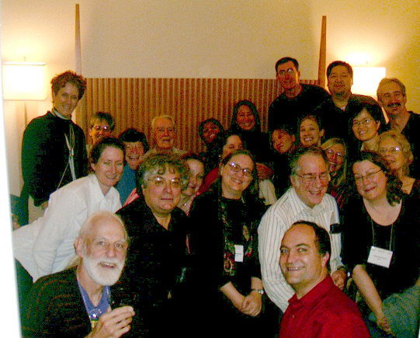
Celebrating Peter’s 80th birthday at the fall meeting of the Acoustical Society of America in Minneapolis, October 20, 2005

“I was also able to create a Phonetics Laboratory group. For me, the people mattered more than the instruments. Of course we tried to get good computers and all the hardware we needed. But getting a group that functioned together and saw themselves as a working unit was of prime importance. I enjoyed going around every day, chatting to everyone, and lunching in the lab with as many people as possible. It was also useful to have weekly lab meetings which all the staff, students and faculty were expected to attend, even if only for the first ten minutes when we talked about what was going on. Building a research group who felt that they had a stake in the development of the lab taught me their varied ideas from statistics to engineering, and the philosophy of linguistics. And interacting with bright students keeps one intellectually honest.”
--Peter, on his home page
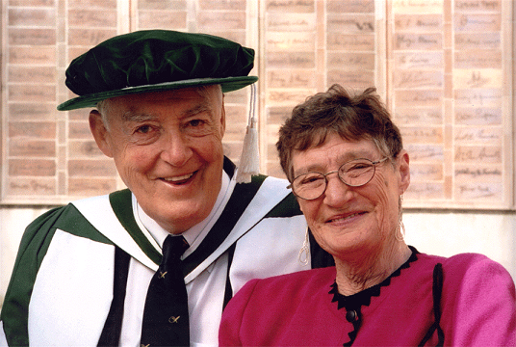

Tomorrow

If I should die tomorrow
Grieve not for me
Sorrow’s fine for those
Who leave too early on their way.
My stay was a full time,
Glowing like a rhyme with unexpected parts
That starts new lines and gives
New twists to older arts

Peter Ladefoged, 2005

